单项选择题（共50题）

1) If the sequence of a cDNA has matches with DNA sequences in the genome, then this genomic DNA is likely to _____.

A) be part of an intron

B) code for an rRNA

C) code for a protein

D) be a regulatory sequence

2) Which of the following techniques would be most appropriate to test the hypothesis that humans and chimps differ in the expression of a large set of shared genes?

A) polymerase chain reactin (PCR)

B) DNA microarray analysis

C) DNA sequencing

D) protein-protein interaction assays

3) Which of the following is a representation of gene density?

A) Humans have 2900 Mb per genome.

B) *C. elegans* has ~20,000 genes.

C) *Fritillaria* has a genome 40 times the size of a human.

D) Humans have ~20,000 protein-encoding genes in 2900 Mb.

4) It is more difficult to identify eukaryotic genes than prokaryotic genes because in eukaryotes _____.

A) there are introns

B) the coding portions of genes are shorter than in prokaryotes

C) there are no start codons

D) the proteins are larger than in prokaryotes

5) Retrotransposons _____.

A) generally move by a cut-and-paste mechanism

B) are found only in animal cells

C) use an RNA molecule as an intermediate in transposition

D) contribute a significant portion of the genetic variability seen within a population of gametes

6) Which of the following can be duplicated in a genome?

A) only DNA sequences

B) only entire sets of chromosomes

C) only entire chromosomes

D) DNA sequences, chromosomes, or sets of chromosomes

7) Unequal crossing over during prophase I can result in one sister chromosome with a deletion and another with a duplication. A mutated form of hemoglobin, so-called hemoglobin Lepore, exists in the human population. Hemoglobin Lepore has a deleted series of amino acids. If this mutated form was caused by unequal crossing over, what would be an expected consequence?

A) Each of the genes in the hemoglobin gene family must show the same deletion.

B) There should also be persons whose hemoglobin contains two copies of the series of amino acids that is deleted in hemoglobin Lepore.

C) The deleted gene must have undergone exon shuffling.

D) The deleted region must be located in a different area of the individual's genome.

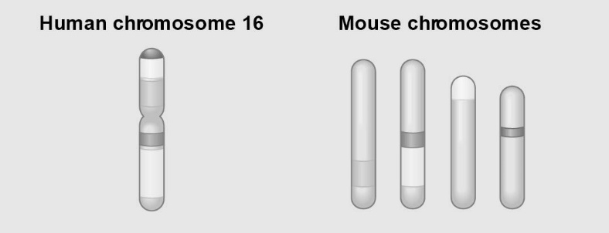

The figure above shows a diagram of blocks of genes on human chromosome 16 and the locations of blocks of similar genes on four chromosomes of the mouse.

8) The movement of these blocks suggests that _____.

A) chromosomal translocations have moved blocks of sequences to other chromosomes

B) DNA sequences within these blocks have become increasingly divergent

C) sequences represented have duplicated at least three times

D) during evolutionary time, these sequences have separated and have returned to their original positions

9) Humans have twenty-three pairs of chromosomes and chimps have twenty-four pairs of chromosomes. What is the most likely explanation for these differences in human and chimp genomes?

A) Errors in mitosis resulted in an additional pair of chromosomes in chimps.

B) In the evolution of chimps, new adaptations resulted from additional chromosomal material.

C) At some point in evolution, human and chimp ancestors reproduced with each other.

D) The common ancestor of humans and chimps had twenty-four pairs of chromosomes. After the two groups evolved, two human chromosomes fused end to end

10) When gene duplication occurs to its ultimate extent by doubling all genes in a genome, what has occurred?

A) pseudogene creation

B) creation of a gene cluster

C) creation of a diploid

D) creation of a polyploid

11) Biologists now routinely test for homology between genes in different species. If genes are determined to be homologous, it means that they are related _____.

A) because of convergent evolution

B) by descent from a common ancestor

C) by chance mutations

D) in function but not structure

12) A microarray is a tool used in genetic research to determine the mRNAs being produced in a particular tissue, and their relative level of expression. Known genes can therefore be assayed for their expression in different situations. One use of the technology is in cancer diagnosis and treatment. If a known gene functions as a tumor suppressor, predict which of the following pieces of evidence would be most useful in diagnosis of a cancer due to a mutation in this tumor-suppressor gene.

A) The tissue sample shows a high level of gene expression relative to a control (noncancerous) sample.

B) The tissue sample responds to treatment with a mitosis-promoting compound.

C) The mRNAs for cyclins and kinases show unusually high levels of expression.

D) The mRNAs for the targeted tumor suppressor sequence are not being produced.

13) Cystic fibrosis is a genetic disorder in homozygous recessives that causes death during the teenage years. If 9 in 10,000 newborn babies have the disease, what are the expected frequencies of the dominant (*A1*) and recessive (*A2*) alleles according to the Hardy-Weinberg model?

A) f(*A1*) = 0.9997, f(*A2*) = 0.0003

B) f(*A1*) = 0.9800, f(*A2*) = 0.0200

C) f(*A1*) = 0.9700, f(*A2*) = 0.0300

D) f(*A1*) = 0.9604, f(*A2*) = 0.0392

14) Suppose 64% of a remote mountain village can taste phenylthiocarbamide (PTC) and must, therefore, have at least one copy of the dominant PTC taster allele. If this population conforms to Hardy-Weinberg expectations for this gene, what percentage of the population must be heterozygous for this trait?

A) 16%

B) 32%

C) 40%

D) 48%

15) For biologists studying a large flatworm population in the lab, which Hardy-Weinberg condition is most difficult to meet?

A) no selection

B) no mutation

C) no gene flow

D) no genetic drift

16) Whenever diploid populations are in Hardy-Weinberg equilibrium at a particular locus, _____.

A) two alleles are present in equal proportions

B) natural selection, gene flow, and genetic drift are acting equally to change an allele's frequency

C) the allele's frequency should not change from one generation to the next

D) individuals within the population are evolving

17) In a Hardy-Weinberg population with two alleles, *A* and *a*, that are in equilibrium, the frequency of the allele *a* is 0.3. What is the frequency of individuals that are homozygous for this allele?

A) 0.09

B) 0.49

C) 0.9

D) 9.0

18) In a Hardy-Weinberg population with two alleles, *A* and *a*, that are in equilibrium, the frequency of allele *a* is 0.2. What is the frequency of individuals that are heterozygous for this allele?

A) 0.020

B) 0.04

C) 0.16

D) 0.32

19) In a Hardy-Weinberg population with two alleles, *A* and *a*, that are in equilibrium, the frequency of allele *a* is 0.1. What is the frequency of individuals with *AA* genotype?

A) 0.20

B) 0.32

C) 0.42

D) 0.81

20) You sample a population of butterflies and find that 56% are heterozygous at a particular locus. What should be the frequency of the recessive allele in this population?

A) 0.08

B) 0.09

C) 0.70

D) Allele frequency cannot be determined from this information.

21) In peas, a gene controls flower color such that *R* = purple and *r* = white. In an isolated pea patch, there are 36 purple-flowering plants and 64 white-flowering plants. Assuming Hardy-Weinberg equilibrium, what is the value of *q* for this population?

A) 0.36

B) 0.64

C) 0.75

D) 0.80

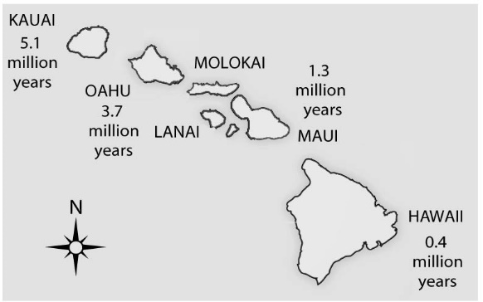

22) Soon after the island of Hawaii rose above the sea surface (somewhat less than one million years ago), the evolution of life on this new island should have been most strongly influenced by _____.

A) a genetic bottleneck

B) the founder effect

C) habitat differentiation

D) sexual selection

23) The Dunkers are a religious group that moved from Germany to Pennsylvania in the mid-1700s. They do not marry with members outside their own immediate community. Today, the Dunkers are genetically unique and differ in gene frequencies, at many loci, from all other populations including those in their original homeland. Which of the following likely explains the genetic uniqueness of this population?

A) population bottleneck and Hardy-Weinberg equilibrium

B) heterozygote advantage and stabilizing selection

C) founder effect and genetic drift

D) mutation and natural selection

24) An earthquake decimates a ground-squirrel population, killing 98% of the squirrels. The surviving population happens to have broader stripes, on average, than the initial population. If broadness of stripes is genetically determined, what effect has the ground-squirrel population experienced during the earthquake?

A) directional selection

B) disruptive selection

C) a genetic bottleneck

D) a founder event

25) Which of the following is the most predictable outcome of increased gene flow between two populations?

A) lower average fitness in both populations

B) higher average fitness in both populations

C) decreased genetic difference between the two populations

D) increased genetic difference between the two populations

26) In 1986, a nuclear power accident in Chernobyl, USSR (now Ukraine), led to high radiation levels for miles surrounding the plant. The high levels of radiation caused elevated mutation rates in the surviving organisms, and evolutionary biologists have been studying rodent populations in the Chernobyl area ever since. Based on your understanding of evolutionary mechanisms, which of the following most likely occurred in the rodent populations following the accident?

A) Mutations caused major changes in rodent physiology over time.

B) Mutation caused the fixation of new alleles.

C) Mutation caused genetic drift and decreased fitness.

D) Mutation led to increased genetic variation.

27) Over time, the movement of people on Earth has steadily increased. This has altered the course of human evolution by increasing _____.

A) nonrandom mating

B) geographic isolation

C) gene flow

D) genetic drift

28) You are maintaining a small population of fruit flies in the laboratory by transferring the flies to a new culture bottle after each generation. After several generations, you notice that the viability of the flies has decreased greatly. Recognizing that small population size is likely to be linked to decreased viability, the best way to reverse this trend is to _____.

A) reduce the number of flies that you transfer at each generation

B) cross your flies with flies from another lab

C) transfer only the largest flies

D) change the temperature at which you rear the flies

29) The restriction enzymes of bacteria protect the bacteria from successful attack by bacteriophages, whose genomes can be degraded by the restriction enzymes. The bacterial genomes are not vulnerable to these restriction enzymes because bacterial DNA is methylated. This situation selects for bacteriophages whose genomes are also methylated. As new strains of resistant bacteriophages become more prevalent, this in turn selects for bacteria whose genomes are not methylated and whose restriction enzymes instead degrade methylated DNA. The outcome of the conflict between bacteria and bacteriophage at any point in time results from _____.

A) neutral variation

B) evolutionary imbalance

C) heterozygote advantage

D) frequency-dependent selection

30) When imbalances occur in the sex ratio of sexual species that have two sexes (that is, other than a 50:50 ratio), the members of the minority sex often receive a greater proportion of care and resources from parents than do the offspring of the majority sex. This is most clearly an example of _____.

A) frequency-dependent selection

B) balancing selection

C) stabilizing selection

D) sexual selection

In a very large population, a quantitative trait has the following distribution pattern.

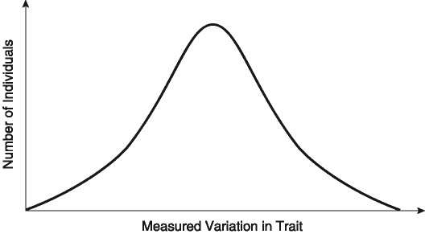

31) If there is no gene flow, the curve shifts to the left or to the right, and the population size consequently increases over successive generations, which of the following is most likely occurring?

A) immigration or emigration

B) genetic drift

C) disruptive selection

D) directional selection

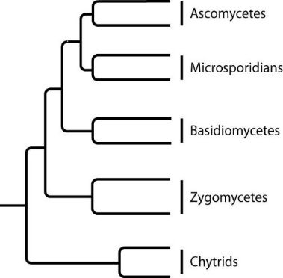 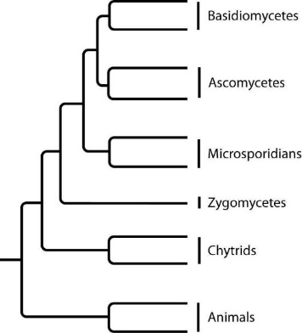

**I. II.**

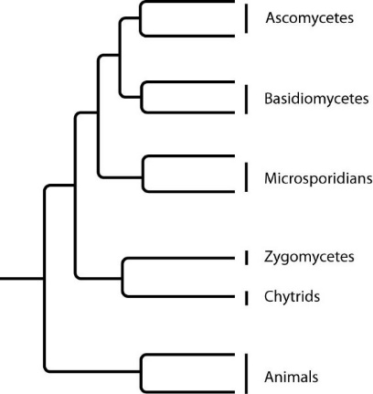 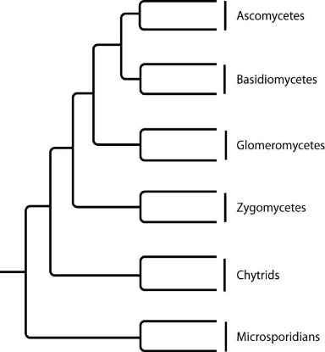

**III. IV.**

32) Which tree depicts the closest relationship between zygomycetes and chytrids?

A) I

B) II

C) III

D) IV

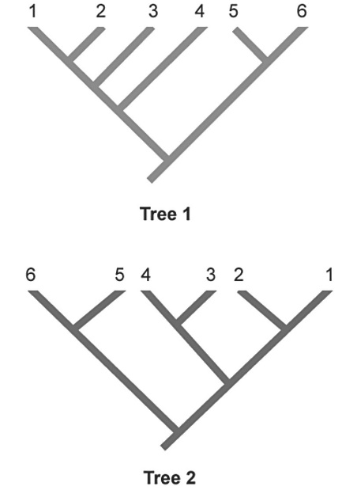

33) In the phylogenetic trees above, numbers represent species and the same species are shown in both trees. Which two species are represented as sister species in Tree 2 but are not shown as sister species in Tree 1?

A) 1 and 2

B) 2 and 3

C) 3 and 4

D) 4 and 5

34) The best classification system is that which most closely _____.

A) unites organisms that possess similar morphologies

B) conforms to traditional, Linnaean taxonomic practices

C) reflects the basic separation of prokaryotes from eukaryotes

D) reflects evolutionary history

35) Based on this tree, which statement is NOT correct?

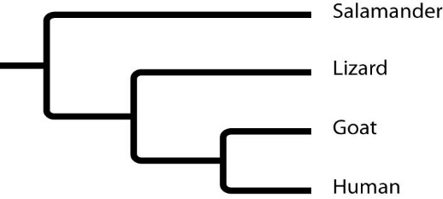

A) The salamander lineage is a basal taxon.

B) Lizards are more closely related to salamanders than to humans.

C) Salamanders are as closely related to goats as to humans.

D) Salamanders are a sister group to the group containing lizards, goats, and humans.

36) Which of the following pairs are the best examples of homologous structures?

A) bat wing and bird wing

B) owl wing and hornet wing

C) bones in the bat wing and bones in the human forelimb

D) eyelessness in the Australian mole and eyelessness in the North American mole

37) Which of the following would be useful in creating a phylogenetic tree of a taxon?

I) morphological data from fossil species

II) genetic sequences from living species

III) behavioral data from living species

A) I

B) II

C) III

D) I, II, and III

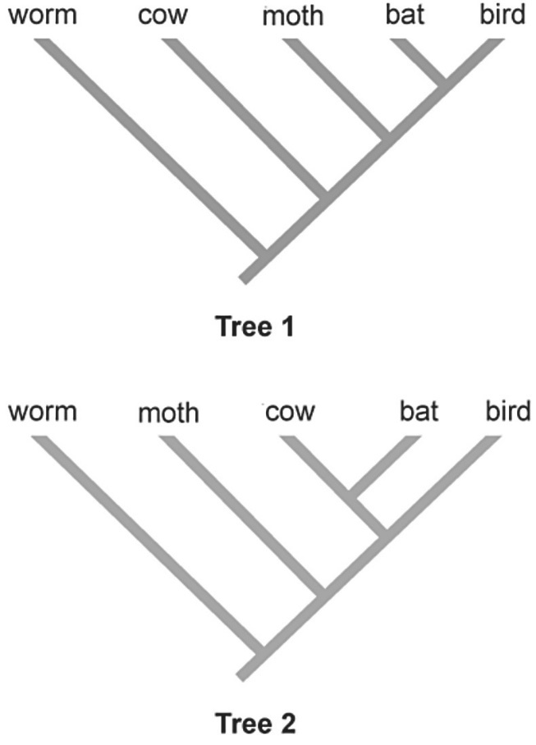

38) Applying the principle of parsimony to the trait "ability to fly," which of the two phylogenetic trees above is better?

A) Tree 1

B) Tree 2

C) Both trees are equally parsimonious.

D) Since the trees show different evolutionary relationships, you cannot determine which is more parsimonious.

39) To apply parsimony to constructing a phylogenetic tree, _____.

A) choose the tree that assumes all evolutionary changes are equally probable

B) choose the tree in which the branch points are based on as many shared derived characters as possible

C) choose the tree with the fewest branch points

D) choose the tree that represents the fewest evolutionary changes, either in DNA sequences or morphology

40) Eukaryotes that are not closely related and that do not share many anatomical similarities can still be placed together on the same phylogenetic tree by comparing their _____.

A) plasmids

B) mitochondrial genomes

C) homologous genes that are poorly conserved

D) homologous genes that are highly conserved

41) Which of the following is the correct sequence of events in the origin of life?

I. formation of protobionts

II. synthesis of organic monomers

III. synthesis of organic polymers

IV. formation of DNA-based genetic systems

A) I, II, III, IV

B) I, III, II, IV

C) II, III, IV, I

D) II, III, I, IV

42) Which of the following is a defining characteristic that all protocells had in common?

A) the ability to synthesize enzymes

B) the ability to replicate RNA

C) RNA genes

D) a surrounding membrane or membrane-like structure

43) The first genetic material on Earth was probably _____.

A) DNA produced by reverse transcriptase from abiotically produced RNA

B) DNA molecules whose information was transcribed to RNA and later translated in polypeptides

C) oligopeptides located within protobionts

D) self-replicating RNA molecules

44) If the half-life of carbon-14 is about 5730 years, then a fossil that has one-sixteenth the normal proportion of carbon-14 to carbon-12 should be about how many years old?

A) 2800

B) 11,200

C) 16,800

D) 22,900

45) What is thought to be the correct sequence of these events, from earliest to most recent, in the evolution of life on Earth?

1. origin of mitochondria

2. origin of multicellular eukaryotes

3. origin of chloroplasts

4. origin of cyanobacteria

5. origin of fungal-plant symbioses

A) 4, 1, 3, 2, 5

B) 4, 1, 2, 3, 5

C) 4, 3, 2, 1, 5

D) 4, 3, 1, 5, 2

46) Which of these observations gives the most support to the endosymbiotic theory for the origin of eukaryotic cells?

A) the existence of structural and molecular differences between the plasma membranes of prokaryotes and the internal membranes of mitochondria and chloroplasts

B) the size disparity between most prokaryotic cells and most eukaryotic cells

C) the similarity in size between the cytosolic ribosomes of prokaryotes and the ribosomes within mitochondria and chloroplasts D) the observation that some eukaryotic cells lack mitochondria

47) Which of the following was derived from an ancestral cyanobacterium?

A) flagella

B) mitochondrion

C) chloroplast

D) mitosome

48) An early consequence of the release of oxygen gas by plant and bacterial photosynthesis was to _____.

A) change the atmosphere from oxidizing to reducing

B) make it easier to maintain reduced molecules

C) prevent the formation of an ozone layer

D) cause iron in ocean water and terrestrial rocks to rust (oxidize)

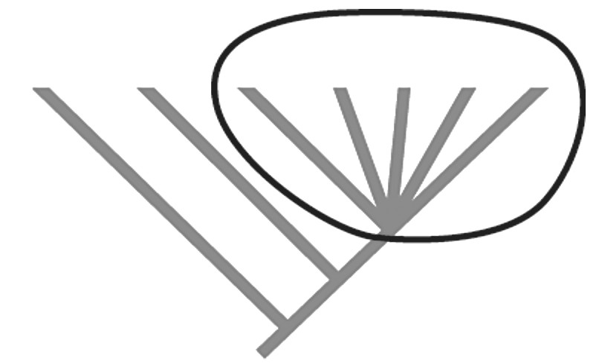

49) What does the circled part of the phylogenetic tree above indicate?

A) an adaptive radiation

B) an adaptive radiation and rapid speciation

C) rapid speciation

D) a mass extinction event

50) Endosymbiosis is an evolutionary theory that explains the origin of eukaryotes and suggests a specific order in which this might have occurred. Ancestral cells engulfed and then began to use the metabolic processes of the smaller cells. Based on shared core processes and features, which statement most accurately describes the order, the theory and the evolutionary implications for all organisms within domain Eukarya?

A) Ancestral heterotrophic eukaryotes most likely engulfed both a heterotrophic and an autotrophic prokaryote, whereas ancestral photosynthetic eukaryotes probably provided the host cell for the first mitochondria. Over time, natural selection favored these relationships and these cells became ancestors of all eukaryotes.

B) All ancestral eukaryotes would have most likely consumed a nucleus-like prokaryote that eventually became the eukaryotic nucleus. These new eukaryotic cells would have had an advantage over prokaryotic cells by acquiring a nuclear command center for regulating cellular activities.

C) As Earth was becoming more aerobic, mitochondria would have provided an advantage to host cells by converting "toxic" oxygen into energy for heterotrophic cells. Since mitochondria are found in all eukaryotes, these combinations likely evolved first. Photosynthetic eukaryotes probably acquired an autotrophic prokaryote, which developed an advantageous symbiotic relationship with the host cell.

D) As carbon dioxide levels were increasing over time, natural selection would have favored organisms that acquired a photosynthetic prokaryote to convert carbon dioxide into sugars. These would have likely been the first eukaryotic cells. At which point, these ancestral cells engulfed mitochondria-like prokaryotes that would have provided an even greater advantage for cells in this environment.